1.WWW and Web Development

* What is the World Wide Web (WWW) and how does it differ from the internet?

The Internet is a global network of interconnected computers, while the World Wide Web (WWW) is a system of interlinked documents and resources accessed via the internet

* Explain the basic structure of a web page. What are the essential elements?

A web page's basic structure involves a <doctype> declaration, an <html> root element, a <head> section, and a <body> section. The DOCTYPE specifies the HTML version, while the html element contains all other elements. The <head> holds metadata like the title and links to external stylesheets and scripts, and the <body> contains the visible content.

Eg:

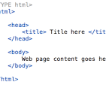

Essential Elements for a Basic Web Page:

* <doctype> declaration: Specifies the HTML version.
* <html> element: The root element of the document.
* <head> section: Contains metadata like title and links to external resources.
* <body> section: Contains the visible content of the webpage.
* Title (<title>): The title of the web page that appears in the browser tab.
* Basic content elements: Headings, paragraphs, links, images, lists, etc.
* What is the role of HTML, CSS, and JavaScript in web development?

In web development, HTML provides the foundational structure and content of a webpage, CSS styles the page's visual presentation, and JavaScript adds interactivity and dynamic behavior. Together, they create the entire user experience on a website.

HTML (HyperText Markup Language):

* **Structure and Content:**

HTML defines the basic structure of a web page, including headings, paragraphs, lists, images, links, and other elements.

* **Semantic Meaning:**

HTML elements provide semantic meaning, helping browsers and search engines understand the content and its purpose.

* **Foundation:**

HTML forms the foundation upon which CSS and JavaScript build the visual and interactive aspects of a webpage.

CSS (Cascading Style Sheets):

* **Visual Presentation:**

CSS is responsible for the visual styling of a webpage, including colors, fonts, layout, and spacing.

* **Separation of Concerns:**

CSS separates presentation from the content, making it easier to maintain and update the visual design of a website.

* **Responsiveness:**

CSS allows developers to create responsive designs that adapt to different screen sizes and devices.

JavaScript:

* **Interactivity and Dynamic Content:**

JavaScript adds interactivity and dynamic content to a webpage, allowing users to interact with elements and have a more engaging experience.

* **Behavior and Logic:**

JavaScript controls the behavior of web elements, such as handling form submissions, updating content, and creating animations.

* **Client-Side Functionality:**

JavaScript primarily operates on the client-side (in the user's browser), making it a powerful tool for creating interactive user interfaces.

In essence, HTML provides the "what," CSS provides the "how it looks," and JavaScript provides the "how it behaves" for a webpage.

* Describe the difference between static and dynamic web pages.

Static Web Page

Static Web pages are very simple. It is written in languages such as HTML, JavaScript, CSS, etc. For static web pages when a server receives a request for a web page, then the server sends the response to the client without doing any additional process. These web pages are seen through a web browser. In static web pages, Pages will remain the same until someone changes it manually.

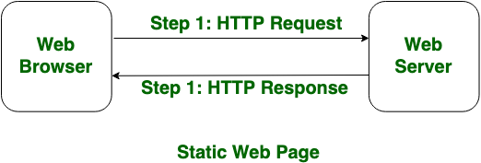

Dynamic Web Page

Dynamic Web Pages are written in languages such as CGI, AJAX, ASP, ASP.NET, etc. In dynamic web pages, the Content of pages is different for different visitors. It takes more time to load than the static web page. Dynamic web pages are used where the information is changed frequently, for example, stock prices, weather information, etc.

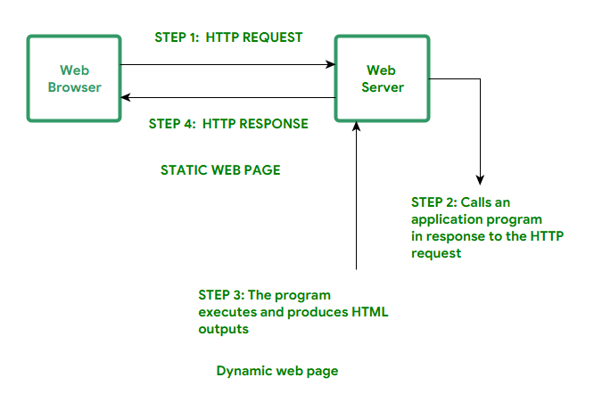

| **Static Web Page** | **Dynamic Web Page** |
| --- | --- |
| In static web pages, Pages will remain same until someone changes it manually. | In dynamic web pages, Content of pages are different for different visitors. |
| Static Web Pages are simple in terms of complexity. | Dynamic web pages are complicated. |
| In static web pages, Information are change rarely. | In dynamic web page, Information are change frequently. |
| Static Web Page takes less time for loading than dynamic web page. | Dynamic web page takes more time for loading. |
| In Static Web Pages, database is not used. | In dynamic web pages, database is used. |
| Static web pages are written in languages such as: HTML, JavaScript, CSS, etc. | Dynamic web pages are written in languages such as: CGI, AJAX, ASP, ASP.NET, etc. |
| Static web pages does not contain any application program . | Dynamic web pages contains application program for different services. |
| Static web pages require less work and cost in designing them. | Dynamic web pages require comparatively more work and cost in designing them. |

2. Web Applications and Types of Web Applications

* What is a web application, and how does it differ from a website?

A website delivers information, while a web application is interactive and allows users to perform actions or manipulate data. Think of a website as a brochure and a web application as a program you use through your browser.

* Name and describe three different types of web applications.

Three main types of web applications are: static web applications, dynamic web applications, and single-page applications (SPAs). Static apps serve pre-defined content, dynamic apps generate content based on user interaction, and SPAs load once and update content dynamically.

1. Static Web Applications:

* **Description:**

These applications serve pre-defined content, meaning the content is the same for every user and does not change based on user interaction or data from a database.

* **Examples:**

Simple websites with static content like blog posts, informational pages, or portfolios.

* **Characteristics:**

Typically built using HTML, CSS, and JavaScript, with no or minimal server-side processing. They are simple to develop and deploy.

2. Dynamic Web Applications:

* **Description:**

Dynamic web applications generate content based on user interaction and data from a server or database.

* **Examples:**

Social media platforms (like Facebook or Instagram), e-commerce websites (like Amazon or Shopify), and online banking platforms.

* **Characteristics:**

They require server-side scripting languages like PHP, Python, or Java to process user requests and interact with databases.

3. Single-Page Applications (SPAs):

* **Description:**

SPAs load a single HTML page and update content dynamically using JavaScript, without requiring full page reloads.

* **Examples:**

Online gaming websites, web-based office suites like Google Docs, and many modern web applications.

* **Characteristics:**

They offer a user-friendly experience by providing rapid navigation and a sense of app-like functionality within a web browser.

* What are the advantages and disadvantages of Single Page Applications (SPAs) compared to Multi-Page Applications (MPAs)?  
  Single Page Applications (SPAs) offer advantages like fast navigation and a smooth user experience due to dynamic content updates without page reloads. However, SPAs can have slower initial load times and may not be as SEO-friendly as Multi-Page Applications (MPAs). MPAs, while providing better SEO and faster initial load times, can have slower navigation and less seamless user experience due to page reloads.
* SPAs (Single Page Applications):
* Advantages:
* **Faster and More Fluid Navigation:**
* SPAs load once and update content dynamically, resulting in a smoother user experience with quick transitions between sections.
* **Improved Responsiveness:**
* Since content is updated on the client-side, SPAs are generally faster and more responsive than MPAs, especially on slower internet connections.
* **Better Caching:**
* SPAs can cache local data effectively, leading to faster loading times on subsequent visits.
* **Simpler User Experience:**
* SPAs offer a simpler, more linear user experience, with a desktop-like feel.
* Disadvantages:
* **Slower Initial Load Time:**
* SPAs typically require a longer initial load time because they load the entire application, including all assets, on the first page load.
* **Poorer SEO Optimization:**
* Search engines may have difficulty indexing SPAs because they rely heavily on JavaScript, which can make it challenging for crawlers to understand the content.
* **Browser Resource Usage:**
* SPAs can consume more browser resources due to the complexity of managing the single page and handling client-side updates.
* **Security Concerns:**
* SPAs can be more vulnerable to certain security threats, such as cross-site scripting (XSS) attacks, due to the nature of client-side rendering.
* **Development Complexity:**
* Developing SPAs can be more complex than MPAs, requiring a deeper understanding of frameworks and client-side technologies like JavaScript.
* MPAs (Multi-Page Applications):
* Advantages:
* **Better SEO:**
* MPAs are generally considered more SEO-friendly because each page has its own URL, making it easier for search engines to index and rank.
* **Faster Initial Load Time:**
* MPAs can have faster initial load times because they load only the content of the current page, not the entire application.
* **Simpler Development:**
* MPAs are often easier to develop and maintain than SPAs, as they don't require as much client-side logic.
* **Better Analytics:**
* MPAs can provide more comprehensive analytics data, allowing developers to track user behavior across different pages.
* **Scalability:**
* MPAs can be easily scaled by adding new pages, making them well-suited for content-heavy websites.
* Disadvantages:
* **Slower Navigation:**
* Navigation between different sections of an MPA can be slower than in SPAs, as each page requires a full page load.
* **Less Smooth User Experience:**
* The need for page reloads can result in a less seamless and fluid user experience compared to SPAs.
* **Limited Interactivity:**
* MPAs can have limited interactivity compared to SPAs, as they rely on server-side rendering and page reloads.
* **Potential for Slower Performance:**
* MPA performance can degrade on slower internet connections due to the need for page reloads.
* **Scalability Challenges:**
* While MPAs can be scaled by adding pages, maintaining consistency and a cohesive user experience across many pages can be challenging.

3. Web Client and Web Server

* What is a web client, and how does it interact with a web server?

A web client is any software application that initiates communication with a web server to request data or resources. The most common example is a web browser, but it can also include mobile apps or other tools. The interaction between a web client and a web server involves a client sending an HTTP request, and the server responding with an HTTP response containing the requested data

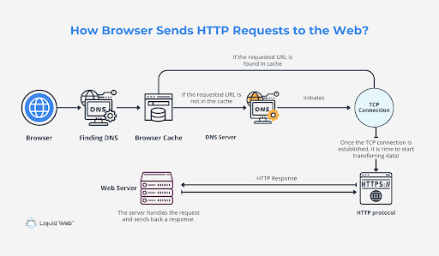

How it works:

1. Client Request:

The client (e.g., web browser) sends an HTTP request to the web server, specifying what data or resource it needs.

2. Server Processing:

The web server receives the request and processes it. This might involve retrieving data from a database or generating dynamic content.

3. Server Response:

The server then sends an HTTP response back to the client, which includes the requested data (e.g., HTML code for a webpage) and instructions for how to render it.

4. Client Rendering:

The client receives the HTTP response and renders the data, displaying it to the user.

In summary, the web client acts as the user's interface, requesting information from the web server, which then provides the requested resources for the client to display.

* Explain the role of a web server in delivering web content to users.

A web server's primary role is to host websites and deliver web content to users over the internet. It acts as a central hub, receiving requests from web browsers (clients) and sending back the requested web pages and resources. This process ensures that users can access and view the content hosted on the server's website.

Here's a more detailed explanation:

Receiving Requests:

When a user types a website address (URL) into their browser, the browser sends an HTTP (Hypertext Transfer Protocol) request to the corresponding web server.

Processing Requests:

The web server receives this request and processes it to determine the requested content.

Delivering Content:

Once the server identifies the content (e.g., an HTML page, image, video), it sends it back to the user's browser.

Facilitating Communication:

The web server acts as the intermediary, facilitating the communication between the user's browser and the website's content.

Handling Different Content Types:

Web servers can handle both static and dynamic content. Static content (like images and HTML files) is delivered as is, while dynamic content (like data from a database) is generated by the server based on the user's request.

Using HTTP/HTTPS:

Web servers primarily use the HTTP protocol for communication. HTTPS provides a secure connection, especially for sensitive information like login details or payment information.

* What is the purpose of a server-side language, and how does it differ from a client-side language?

The server side is used as a back end where data is processed and is not visible to the client user. On the client side, the user is allowed to access the code written after verifying the user's need. Server-side scripting allows the back-end developer to hide the source code from the user.

4. Client-Server Communication

* Describe the process of client-server communication in a typical web application.

In a typical web application, client-server communication works through a request-response model. The client (like a web browser) initiates the communication by sending a request to the server, which might be a web server. The server then processes the request and sends back a response, completing the communication cycle.

Here's a more detailed breakdown:

1. Client Initiates Request:

The client, such as a web browser, initiates a request to the server. This request can be for various purposes, including retrieving a web page, submitting a form, or performing a search.

2. Server Processes Request:

The server receives the client's request and processes it according to the specific protocol, like HTTP. It might involve retrieving data from a database, performing calculations, or generating a response based on the request.

3. Server Sends Response:

Once the server has processed the request, it sends a response back to the client. This response could be the requested web page, the result of a form submission, or any other data or information.

4. Client Receives Response:

The client receives the server's response and displays it to the user or uses it as needed.

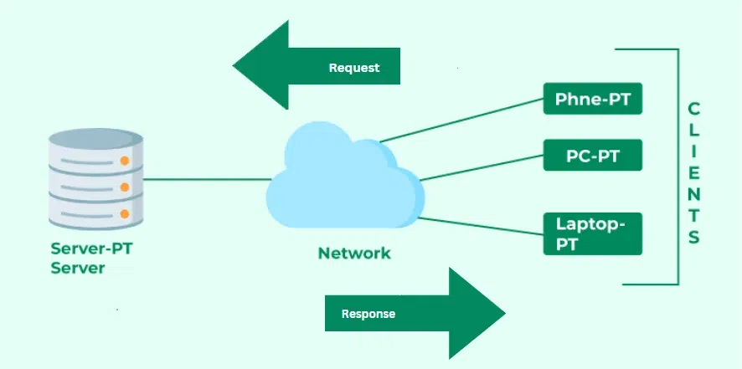

* What is a RESTful API, and how does it facilitate client-server communication?

A RESTful API is an architectural style for building web services that utilizes the principles of Representational State Transfer (REST). It facilitates client-server communication by using standard HTTP methods (GET, POST, PUT, DELETE) to interact with resources, which are identified by unique URLs. This uniform interface ensures simplicity and scalability, making RESTful APIs ideal for web and mobile development.

 more detailed explanation:

1. Representational State Transfer (REST):

* REST is a set of architectural principles that guide the design of web services.
* It emphasizes the transfer of data representations (like JSON or XML) between client and server.
* Key principles include statelessness, client-server architecture, uniform interface, and cacheability.

2. Client-Server Communication:

* RESTful APIs follow a client-server model where a client (e.g., a web browser, mobile app) requests resources from a server.
* The server then responds with the requested resource or an error message.
* This interaction is based on HTTP requests and responses.

3. Uniform Interface:

* RESTful APIs use a standardized interface, meaning all requests follow a consistent format.
* HTTP methods (GET, POST, PUT, DELETE) are used to perform actions on resources.
* This uniformity simplifies development and makes it easier to understand how to interact with the API.

4. Resources and URIs:

* Resources are entities managed by the server, such as data, documents, or services.
* Each resource is uniquely identified by a Uniform Resource Identifier (URI), which is essentially a URL.
* Clients use URIs to access and manipulate resources.

5. Benefits of RESTful APIs:

* **Scalability:**

RESTful APIs are stateless, meaning each request is self-contained, making it easy to scale the system.

* **Simplicity:**

The use of HTTP methods and a consistent approach to accessing resources makes RESTful APIs simple to use and understand.

* **Flexibility:**

RESTful APIs can work with various data formats (JSON, XML, etc.), making them flexible with a wide range of platforms.

* **Performance:**

HTTP is a fast and efficient protocol, allowing RESTful APIs to handle a large number of requests quickly.

* **Security:**

RESTful APIs can use common web security methods like HTTPS, OAuth, and JWT to ensure secure communication.

* Explain the concept of a session in the context of web development.

In web development, a session represents a continuous period of interaction between a user and a web application. It's a way to track and maintain information about a specific user across multiple web pages and requests, overcoming the limitations of HTTP's stateless nature

5. HTTP and HTTP Methods

* What is HTTP, and why is it essential for web communication?

HTTP, which stands for Hypertext Transfer Protocol, is the fundamental protocol that enables communication between web browsers and servers, allowing for the transfer of data like web pages, images, and other resources. It's essential for web communication because it provides a standard way for clients (like your web browser) to request information from servers and for servers to respond with the requested data.

Here's why HTTP is so important:

* **Data Transfer:**

HTTP facilitates the exchange of data in the form of hypertext documents, which are the foundation of web pages.

* **Client-Server Model:**

It operates on a client-server model, where a client (like your browser) initiates a request to a server, and the server responds with the requested data.

* **Web Communication Standard:**

HTTP provides a standardized way for web browsers and servers to communicate, ensuring that different web browsers can interact with different web servers.

* **Foundation of the Web:**

HTTP is the core protocol that makes it possible to access and interact with websites on the internet.

* **Security:**

While HTTP is not inherently secure, HTTPS (HTTP Secure) uses encryption to provide secure communication.

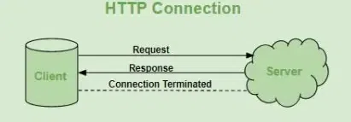

* List and describe the different HTTP methods (e.g., GET, POST, PUT, DELETE). When should each be used?

The most commonly used HTTP methods are:

GET. The GET method is used to retrieve data on a server. ...

POST. The POST method is used to create new resources. ...

PUT. The PUT method is used to replace an existing resource with an updated version. ...

PATCH. The PATCH method is used to update an existing resource. ...

DELETE.

* How does the HTTP request-response cycle work?

The HTTP request-response cycle is the fundamental process behind web communication, where a client (e.g., a web browser) sends a request to a server, and the server responds with the requested information. This interaction involves several steps, including the client initiating the request, the server processing it, and sending back a response.

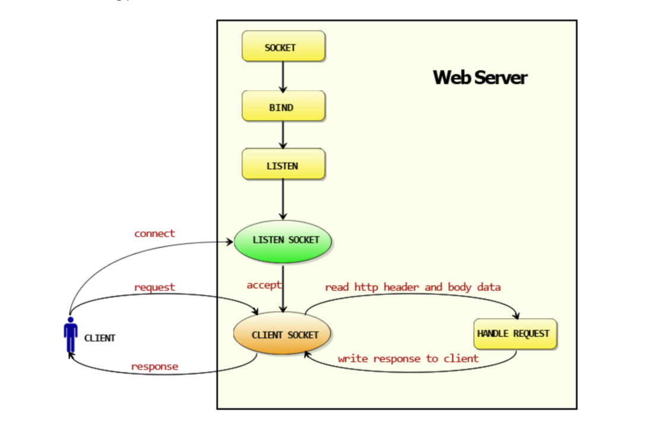

6. HTTPS vs HTTP

* What is HTTPS, and how does it differ from HTTP?

HTTPS is the secure version of HTTP, designed to encrypt data transmission between a web browser and a website. HTTP, on the other hand, sends data in plain text, making it vulnerable to interception and modification.

* **Security:**

HTTPS uses encryption (typically SSL/TLS) to protect data, ensuring it remains confidential and unreadable to eavesdroppers. HTTP transmits data in plain text, offering no such protection.

* **Verification:**

HTTPS verifies the server's identity using digital certificates, confirming the legitimate host of the website. HTTP does not have this verification, making it more susceptible to man-in-the-middle attacks.

* **Purpose:**

HTTPS is crucial for transmitting sensitive information like passwords or credit card details, where data privacy is paramount. HTTP is generally used for basic web browsing and less sensitive data.

* **Protocol:**

HTTPS is an extension of HTTP, incorporating encryption and verification. HTTP is the foundational protocol for web communication.

* **URL:**

HTTPS URLs begin with "https://" (indicating a secure connection), while HTTP URLs start with "http://".

* **Resources:**

HTTPS is slightly more resource-intensive due to encryption and decryption processes. HTTP is less resource-intensive.

* **Ports:**

HTTP typically operates on port 80, while HTTPS uses port 443. \

Summary of differences: HTTP vs. HTTPS

|  |  |  |
| --- | --- | --- |
|  | HTTP | HTTPS |
| Stands for | Hypertext Transfer Protocol | Hypertext Transfer Protocol Secure |
| Underlying Protocols | HTTP/1 and HTTP/2 use TCP/IP. HTTP/3 uses QUIC protocol. | Uses HTTP/2 with SSL/TLS to further encrypt the HTTP requests and responses |
| Port | Default Port 80 | Default Port 443 |
| Used for | Older text-based websites | All modern websites |
| Security | No additional security features | Uses SSL certificates for public-key encryption |
| Benefits | Made communication over the internet possible | Improves website authority, trust, and search engine rankings |

* Why is HTTPS important for modern web applications, and what role does SSL/TLS play?

HTTPS is important for modern web applications because it ensures secure communication between a web server and a client (like a browser) by encrypting data and verifying the server's identity. SSL/TLS, which is the protocol used for establishing HTTPS, provides the necessary encryption and authentication. Without HTTPS, sensitive information transmitted over the internet, such as login credentials and personal data, can be intercepted and read by malicious actors.

7. HTTP Status Codes

* What are HTTP status codes, and why are they important?

HTTP status codes are three-digit responses that a web server sends back to a client (like a browser) after a request is made. They indicate the success or failure of the request and are crucial for understanding what happened during a web transaction. These codes are part of the Hypertext Transfer Protocol (HTTP) and are essential for the communication between clients and servers.

* Why they are important**:**
  + **Communication:** They act as a form of communication between the client and the server, indicating whether the request was successful, if it needs to be redirected, or if an error occurred.
  + **Troubleshooting:** They help developers and users identify and troubleshoot issues with web applications and websites.
  + **SEO:** They play a role in search engine optimization (SEO), as search engines use them to determine the health and reliability of a website.
  + **Performance:** Understanding and managing HTTP status codes can help optimize website performance and user experience.
* List and explain the meaning of the following HTTP status codes: 200, 301, 404, 500.

200 OK:

Indicates that the request was successful, and the server has returned the requested data. It's the most common success status code.

301 Moved Permanently:

Signals that the requested resource has been permanently moved to a new URL. The browser should redirect the user to the new URL.

404 Not Found:

Means the server could not find the requested resource (e.g., a page). It's a common error code indicating a broken link.

500 Internal Server Error:

Indicates a problem on the server's side that prevents it from fulfilling the request. This can be due to various reasons, such as a configuration issue or a server error.